SUNDAY | MONDAY | TUESDAY | WEDNESDAY | THURSDAY | FRIDAY | SATURDAY
 |  |  |  |  |  | 1
2 | 3 | 4 | 5 | 6 | 7 | 8
9 | 10  Summer Camp Begins  (Father’s Day Arts & Crafts) | 11  Flag Day Arts & Crafts  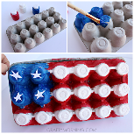 | 12  Wacky Wednesday  Colorful Day | 13  Father’s Day Breakfast! | 14  CENTER CLOSED  FOR STAFF DEVELOPMENT TRAINING! | 15
16 | 17  Slime Day | 18  Outdoor Activities  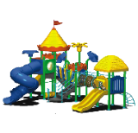 | 19  Wacky Wednesday | 20  Cooking Day | 21  Kid Movie Day | 22
23 | 24  Science Day | 25  Reading Day! | 26  Wacky Wednesday | 27  Cooking Day | 28  Show & Tell Day | 29
Summer Events at Thankful Learning Center, Inc.
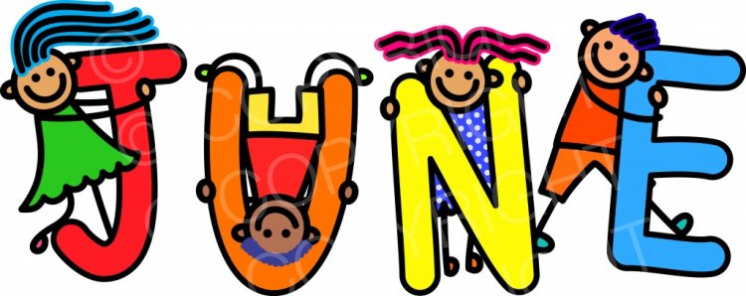

SUNDAY | MONDAY | TUESDAY | WEDNESDAY | THURSDAY | FRIDAY | SATURDAY
30 (JUNE) | 1  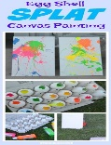  Egg Shell Splat Painting | 2  4th of July Celebration!  (Moon Bounce) | 3  Wacky Wednesday  Wear Red, White, & Blue – Patriot Day! | 4  CENTER CLOSED FOR INDEPENDENCE DAY! | 5  Kid Movie Day | 6
7 | 8  Math Day | 9  Trip to Phila. Zoo! | 10  Wacky Wednesday  Future Day (What do you want to be?) | 11  Cooking Day | 12  Show & Tell Day | 13
14 | 15  Play Dough Day  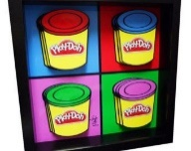 | 16  Experiment Day | 17  Wacky Wednesday | 18  Cooking Day | 19  Kid Movie Day | 20  Trip to Clementon Park & SplashWorld
21 | 22  Oobleck Day  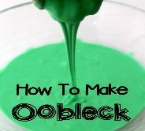 | 23  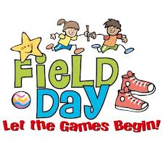  Field Day | 24  Wacky Wednesday | 25  Christmas in July | 26  Kid Movie Day | 27
28 | 29  Reading Day! | 30  Trip to G.S. Discovery Museum | 31  Wacky Wednesday  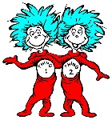 | 1 (AUGUST) | 2 (AUGUST) | 3 (AUGUST)
Summer Events at Thankful Learning Center, Inc.

SUNDAY | MONDAY | TUESDAY | WEDNESDAY | THURSDAY | FRIDAY | SATURDAY
28 (JULY) | 29 (JULY) | 30 (JULY) | 31 (JULY) | 1  Cooking Day | 2  Show & Tell Day | 3
4 | 5  Vacation Bible School | 6  Vacation Bible School | 7  Vacation Bible School | 8  Vacation Bible School | 9  Vacation Bible School | 10
11 | 12  Fun With Bubbles | 13  Storybook Land Trip | 14  Wacky Wednesday  Mix Match Day | 15  Cooking Day | 16  Kid Movie Day | 17
18 | 19  Tie Dye Day | 20  Outdoor Activities | 21  Wacky Wednesday  Blue & Gold for TLC | 22  Move-Up Day | 23  Show & Tell Day | 24
25 | 26  CENTER CLOSED FOR STAFF DEVELOPMENT & TRAINING! | 27  CENTER CLOSED FOR STAFF DEVELOPMENT & TRAINING! | 28  CENTER CLOSED FOR STAFF DEVELOPMENT & TRAINING! | 29  CENTER CLOSED FOR STAFF DEVELOPMENT & TRAINING! | 30  CENTER CLOSED FOR STAFF DEVELOPMENT & TRAINING! | 31
Summer Events at Thankful Learning Center, Inc.

